Phase 1: Create App Registration
- Go to Microsoft Entra ID on Azure portal
- Click on App Registration> New Registration
- Add a name to register your application under the Name field.
- Select the appropriate value under Supported account types. I selected Accounts in any organization directory.
- Click on Register.
- Make a note of Application (client) ID and Directory (tenant) ID.
- Click on Add a Redirect URI on the same page.
- Click on Add a platform and select Web.
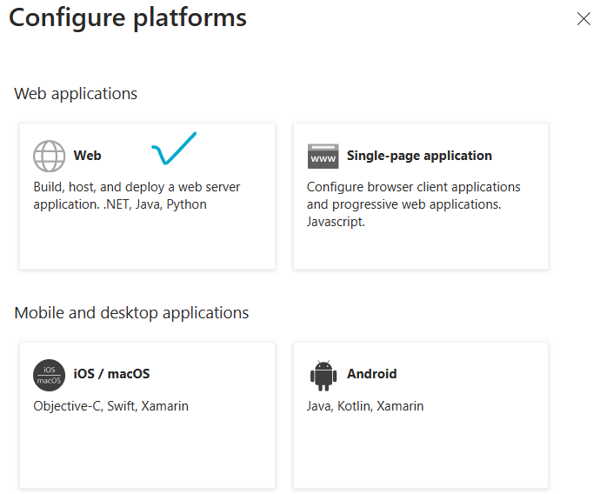
- Enter the Redirect URI. It should be <app URL>/.auth/login/aad/callback
- Enabled Access tokens and ID tokens option.
- Click on Configure.
- After configuration, it should look like this:
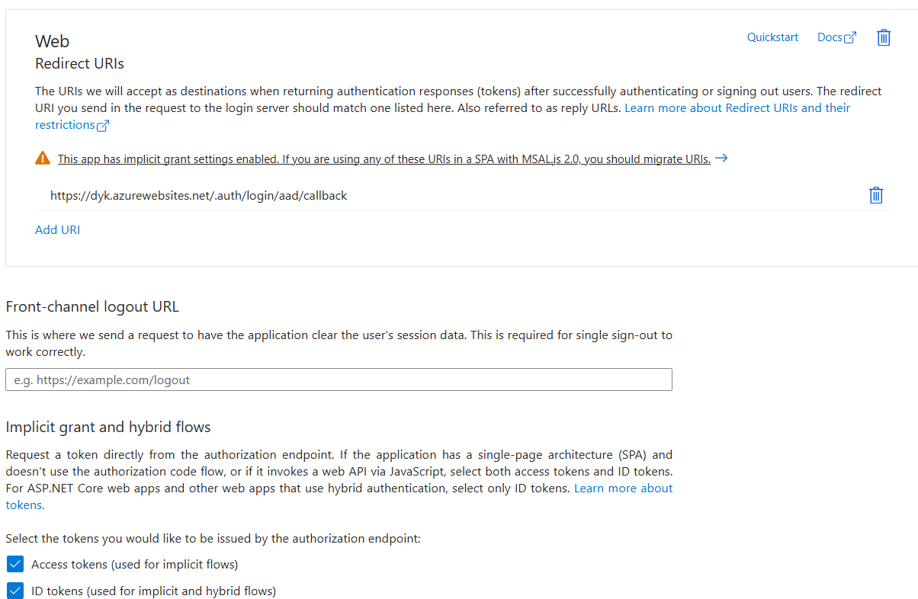

- Click on the Warning sign which says “This app has implicit grant settings enabled.”
- Under Migrate URIs, select your application’s URL.

Phase 2: Certificates & Secrets
- Go to Microsoft Entra ID on Azure portal
- Click on Certificates & Secrets
- Create New client secret
- Add a description for your application
- Select the expiry date.
- Click on Add.

Phase 3: Authentication Configuration
- Go to your application
- Click on Authentication section
- Now click on Add an identity provider
- Select Microsoft from the drop down.
- Under Choose a tenant, keep Workforce configuration option selected.
- Under App Registration, choose Provide the details of an existing app registration.
- In Application (client) ID text box, put the application ID that we had copied in Phase 1.
- Leave other options as Default.
- Click on Add.

- Enter the Redirect URI. It should be <app URL>/.auth/login/aad/callback
- Save the changes.

Phase 4: API Permissions (not needed, but just for information)
- Go to Microsoft Entra ID on Azure portal
- Click on API Permissions
- Select Add a permission
- Go to API my organization uses tab
- Search for “Dataverse”
- Select Delegated Permissions and check the box which says user_impersonation.

